
Telka Company Limited Profile
SUSTAINABLE ICT SOLUTIONS FOR POSTERITY
TELKA COMPANY LIMITED

Company Contacts Details
TELKA Company Limited
P.O BOX 3374
Dar Es Salaam
Email: telkacompanylimited@gmail.com
Tel: +255 758838987/+255 717834862/ +254 721 345359
Amani Place, 7th Floor, Ohio Street, Dar Es Salaam

Executive Summary
The Company’s Business Objectives and requirements:
Telka Company Limited is an Information and Communications Technology (ICT) Services Company registered in the United Republic of Tanzania on October 2018. With the understanding of our client’s vision, we always ensure we meet and exceed their expectations through the use of modern, modular, sustainable and resilient technology and high level of efficiency.
Telka help clients deploy the right technologies cost-effectively and efficiently. We specializes in Data centre infrastructure and general ICT Systems full cycle and ensure project objectives are met in time, at the right cost and with the expected impact.
Telka Limited resources has in-depth understanding, skills and experience of Data centre infrastructure designs, Operations and maintenance including Service level Agreements (SLAs) management. Having been responsible for overseeing the data centre administration tasks including formulation of SLAs as well as Standard operation, emergency operation and maintenance operating procedures, we propose to offer the same services to the bank, but in a cost effective way such as;
The principal decision criteria for any organization considering partnering with a vendor for any mission critical projects is related to the following aspects of the response being considered.
- Company
- Product
- Technology
- Price
Telka Company has a team of internationally certified and accredited data centre specialists continue to deliver world-class solutions in the following areas among others;
- Data centre Infrastructure Design services (Mechanical, Electrical and Plumbing system)
- Data centre Operations consultancy services
- Data centre Technical project management Services
- Network Infrastructure solutions and support

Why use Telka Company for your services?
Telka Company provides solutions and services which optimise and manage the performance of ‘next generation’ IT infrastructures that enable businesses to build and sustain competitive advantage.
Having a team with years of experience in assessing, designing, implementing, managing, and optimising IT and business environments, we are uniquely qualified to help you ensure that your business yields the most from your IT investments.
To achieve this, Telka Company leverages off the Services Operating Architecture framework that governs how our Services and Solutions are planned, built and supported. It ensures consistency across all of our deliverables in all of our projects, underpinning everything we do, and setting us apart from our competition.


When delivering your solution, careful planning ensures that your business requirements and critical success factors are understood. The assessment of this knowledge enables us to recommend an optimal IT Architecture and Technology Solution that is built using effective and methodical program, project and risk management.

Introduction
Telka Company Limited is a technology services firm that helps clients deploy the right technologies cost-effectively, efficiently and in a timely manner. We specializes in Data centre infrastructure and general ICT Systems full life cycle. We ensure project objectives are met in time, at the right cost and with the expected impact. Our guidelines include:
We believe in Lean & Flexible approach: Our attention to detail creates value for our clientele and allows us to remain closer to our engagements and our customers for a more personalised touch.
Expert alignment:Our teams assist clients in aligning technology initiatives with business priorities.Our solutions are based on internationally recognized standards such as TIA, ASHRAE, NFPA, Uptime institute, among others.
Vendor Relationships: All Vendors associated with Telka Company offer the highest level of professional and technical support, and guarantee Telka Company its full backing in the maintenance of its products and services.
Practical & Hands-on: Telka Company has a hands-on and practical approach to projects, guided by best practice and client circumstances.
Strategy:We assist clients identify practical, achievable and cost effective initiatives to achieve desired business objectives.

How we help clients achieve sustainable ICT system

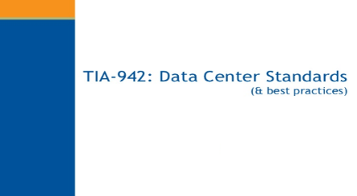
INTERNATIONAL STANDARDS:
A data centre aligned to the international standards such as TIA-942, ASHRAE, NFPA, Uptime institute, EU codes of conduct for efficient data centre operations among others. We help clients undertake gap analysis.
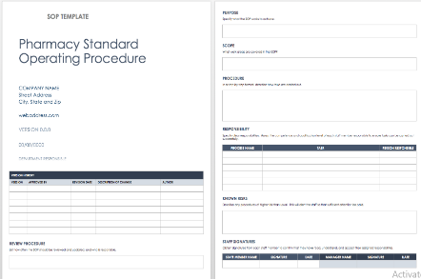
PROCEDURES AND POLICIES:
-Help clients align operations to ensure an uptime of 99.999% through well-articulated, standard operation procedures (SOP), Emergency Operation Procedures (EOP) and Maintenance Operation Procedures (MOP). These are based on industry best-practices.

ENHANCED DATA CENTRE SECURITY:
-Enhanced physical security of the data centre to ensure the integrity of the data centre facility.
-Remote and local Monitoring of critical systems with automated alerts (Email and Text messages)

SERVICE LEVEL AGREEMENT (SLA):
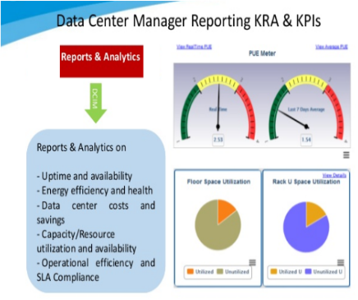
-Through our professional SLA management, we help clients greatly reduce their data centre Total Cost of Ownership (TCO) by extending equipment lifecycle through a well formulated and executed Maintenance regime ensuring 100% SLA compliance.
KEY PERFOMANCE INDEX (KPI):
-To establish Key performance Indicators. What you cannot measure, you cannot improve (If you can’t measure it, you can’t improve it)

Our Services

ICT Infrastructure Solutions and Services
Data centres have remained consistently entrenched as the anchor point of the IT ecosystem for decades. All that time the focus on availability and uptime have been the entire scope of success.Our Data Centre design, Consulting and solution services include:
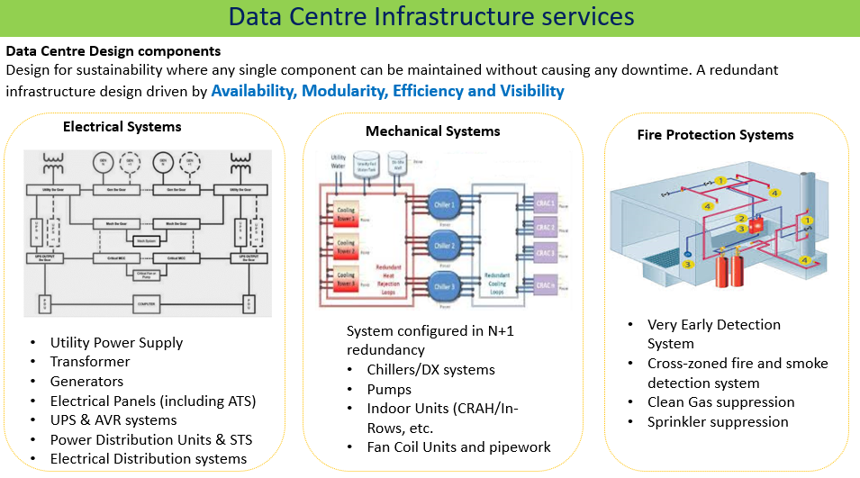
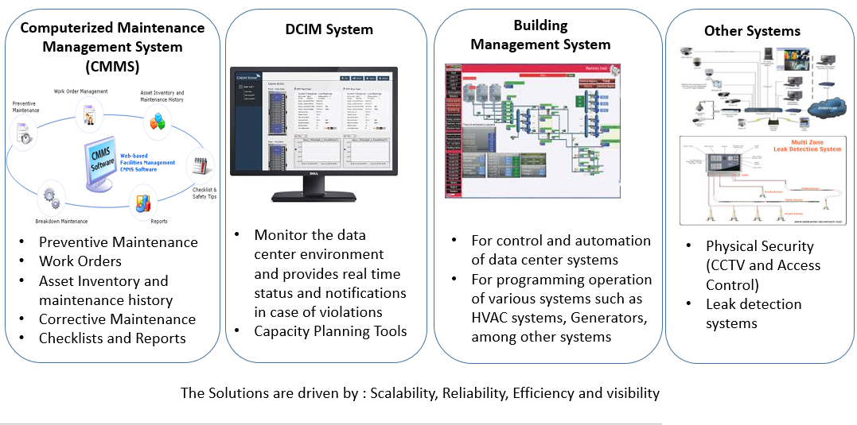
Various Services offered by Telka Company Limited:

Conceptual Designs: Prepare specifications document that exactly matches the client needs and objectives by focusing on specific project requirements while committing to vendor neutrality

Technical Designs: Skilled and experienced team creates an innovative, efficient and cost effective detailed or technical designs

Requirements Analysis: Building a new facility, retrofit, consolidation or decommissioning requires a full requirements analysis as a first step to ensure the end result will be fit for the purpose

Audit & Risk Assessment: Investigating all the areas of the data centre during assessment, from physical infrastructure and operations through to governance. End result is a solid foundation on which to make future decisions related to the data centre facility.

Project Management Services: Deliver data centre project management services ensuring a successful, timely and cost effective delivery of projects.

Integrated Witness Testing: Full and thorough testing of systems upon completion to ensure the facility is fit for purpose in terms of efficiency, resiliency and redundancy.

Site Surveys: Site surveys based on thorough understanding of risks, benefits, and technological challenges from location site suitability and cost perspectiveensuring a smoother, faster, cost effective Solution delivery

Energy Audits: We help assess current energy practices and usage and advise on energy efficiency improvements

Data Centre Tier Reviews: We apply in-depth knowledge of TIA and uptime institute standards to assess overall resiliency and redundancy of the facility

Commissioning Services: Following on from construction and testing, Data Centre Commissioning is essential to ensure that the completed facility is configured for maximum efficiency by examining characteristics of the current IT load, identifying where equipment manufacturers standard specifications are not appropriate, and configuring the supporting infrastructure accordingly.

Feasibility Studies: We conduct data Centre Feasibility to identify the potential ‘risk and reward’ of any new project. We help clients to understand potential ROI, risk factors and the impact of change resulting from any new data centre initiative. This makes organisations to be armed with all the information they need to decide the best route forward.

Operational Strategy Review: We work with clients to align culture, values and business goals to operational data centre strategy and management.This ensures all elements of the data centre, from the physical infrastructure through to the management team, are working together to achieve optimum performance.

Design Reviews: As industry specific specialists, we help review designs done by Architects or engineers without in-depth knowledge in data centres to evaluate whether the data centre best practices have been taken, risk minimised and expected standards of quality and performance have been met.

Tender Documents & Evaluation: Tender documentation has a considerable impact on project timeframes, decision making and overall success. Using our experience we ensure client tender documents are simple, concise and enable objectives to be met

Capacity Planning: Capacity planning is essential for any data centre. Wasted capacity means wasted money whatever the size, age or specification of the facility. Telka’s data centre consulting services help clients to identify capacity issues and causes to enable effective use of space, or negate the need to relocate or extend a data centre, improves efficiencies and ultimately saves costs.

Data Centre Standards: We help clients review and demystify the standards landscape which is normally confusing and this confusion is increased by some standards broadly contradicting each other, while others are open to interpretation.

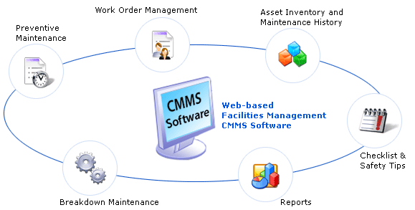
Data centre Facilities Operations and Monitoring Services: Telka offers data centremanagement operations andmonitoring services which are managed by our expert facilities management team. The team have extensive knowledge of ICT infrastructure systems and are highly trained and able to ensure that faults and issues are noticed and appropriate action is taken. We offer annual preventive maintenance and support for all installed systems as well as SLA management services to ensure all services are performed on as per Original Equipment manufacturer (OEM) recommendations and as per industry standards and best practice.

Recruitment and Training: Telka help clients with capacity building services and in partnership with our industry partners offer over-the shoulder training for all systems installed in the data centreand through our partners, we also offer class-room training for all the installed systems. We also help clients and facilitate three levels of training, namely; Over-the Shoulder training, Factory training and Certified Trainings.

Consolidated experience
Telka resources has over 10 years of accumulated data centreexperience and best practices for various industries in the East African Region.
TELKA Engineers have a strong track record in delivering engineering solutions and have been directly responsible for delivering large scale solutions to some of the Leading operators and vendors in East Africa. Below are some of the clients where our engineers, at personal level have offered data centre consultancy services:

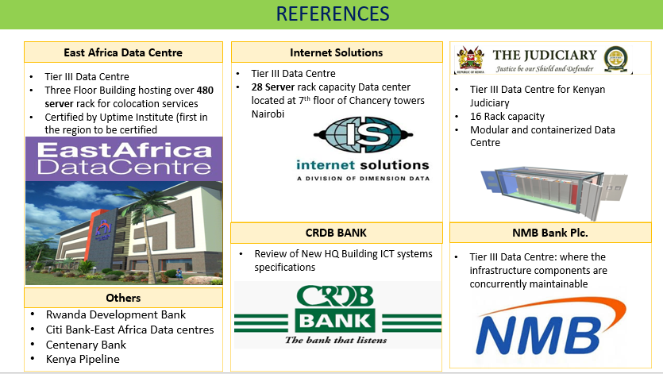

Corporate structure
We have structured our company into strategic business units mainly Corporate, and Engineering Departments. With unrivalled technical capacity, our Technical team delivers efficient execution of projects and offers the necessary support and advice to our clients. We continually undertake research to continuously learn, train and adapt to the fast technology changes in getting solutions for quicker, faster and cost effective products and solutions.
TELKA Company Ltd will continue to focus on pursuing our central value of total and consistent satisfaction to the customer, by providing innovative products, solutions & services and continue to maintain an exceptional leading edge in the provision of world-class solutions and services.

MEP
Engineer
Administrative Assistant
HEAD OF OPERATIONS
Accountant
Network Engineer
Data Centre Engineer
HEAD OF ENGINEERING DIVISION
MANAGING DIRECTOR
SHAREHOLDERS

Directors:

S/N: | NAME | CONTACTS
1. | Kennedy Omondi Onyango | +255 758-838-987
2. | Esther Sakire | +255 717 834-862

Technical Competency
TELKA Company Limited prides itself with having among the best technical talent. Our technical team is led by a dedicated staff of Engineers with rich academic and professional backgrounds. This experience ensures that TELKA Company Ltd solutions are designed, built, tested, operated and maintained with the highest standards of performance and reliability.
Our team comprises individuals trained and certified by internationally recognised firms including;
- Accredited Tier Designer (ATD)-Uptime Institute
- Certified Data Centre Design Professional (CDCDP)-CNet Training
- Data Centre Power (DCP)-CNet Training
- Data Centre Cooling (DCC)-CNet Training
- Certified Data Centre Design (CDCD)-CNet Training
- Data Centre management (DCM)-CNet Training
- Data Centre Efficiency (DCE)-CNet Training
- Masters in Data Centre Leadership and Management-CNet in Conjunction with Anglia Ruskin University-United Kingdom
- Cisco Certified Internetwork Expert (CCIE)-Cisco
- Cisco Certified Networking Professional (CCNP)-Cisco
- Cisco Certified Networking Associate (CCNA)-Cisco
- Project Management Professional (PMP)
- PMI Agile Certified Practitioner (PMI-ACP)

Project Management Methodology

Objective
The purpose of this document is to explain our overall Project Management Methodology “PMM”. Telka Company PMM aims at providing a comprehensive set of project management procedures and techniques to ensure high-quality and repeatable results through the successful and smooth implementation of projects on time and without exceeding budget constraints.
Telka Company Project Management Methodology is aligned with the principles set out by worldwide Project Management Institute (PMI) as defined within “A Guide to the Project Management Body of Knowledge” (PMBOK Guide). The PMBOK is the worldwide standard for best-practice project management. Telka Company’s methodology identifies 5 overlapping groups that must be present in each successful project. The Process Groups overlapping enables project fast-tracking and quicker delivery while keeping the process predictable and controlled.
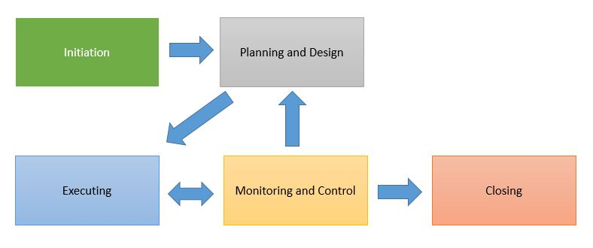

Project Management Team
Telka Company realized the value of proper Project Management to ensure smooth and successful project implementation and as such the Project Management Office and Project Managers from diverse backgrounds across the IT and Construction Industry – All of whom hold certificates varying from CAPM, PMP and PgMp - in addition to a number of PMO functions dedicated to provide the Project Managers with the support required throughout the project lifecycle such as Document Audits & Control, Quality Assurance & Quality Control, and HSE specialists.

Project Management Life Cycle
In line with PMI’s standards, Telka Company utilizes the following processes during project implementations.

Project Initiation
It is the first phase in the Project Lifecycle and essentially involves starting up the project. A project is initiated by defining its purpose and scope, and explaining the solution to be implemented. The Project initiation phase involves steps such as Contract Award, Establishing a Project Charter and appointing the project team.
- Phase Outputs:
- Purchase Order
- Contract (Mutually Agreed upon and signed by Telka Company and Client)
- High-Level Timeline
- Scope Brief (Or Scope Document as outlined in Telka Company’s Technical Proposal in the case of an RFP)
- Project Organization Structure

Project Planning
This involves creating a suite of planning documents to help guide the team throughout the project. The Planning Phase involves steps such as Creating a Project Plan, Resource Plan, Quality Plan, Risk Plan, Testing Plan, Communication Plan and Procurement Plan. Once the plans are developed and finalized internally within Telka Company,Telka Company’s PM will obtain Client’s approval to ensure that a baseline is established against which both parties can track the project during the execution phase.
- Phase Outputs:
- Detailed Program of Works / Project Baseline
- Project Quality Plan
- Risk Management Plan
- Communication Plan
- Site Requirements Document
- Testing Plans & Acceptance Criteria
- Resource Plan
- Design Drawings
- Technical Submittals
- HSE Plan

Project Execution
This is the phase in which the deliverables are physically built and presented for acceptance. While each deliverable is being constructed, a group of management processes are undertaken to monitor and control the deliverables being output by the project. These processes include managing time, cost, quality, change, risks and issues, as well as customer acceptance and project communication.
- Phase Output:
- Project Deliverables

Monitor and Control
Regularly measures and monitors progress to identify variances from the Project baseline so that corrective action can be taken when necessary to meet project objectives.
- Phase Outputs:
- Project Status Reports & Project Meeting Minutes
- RAG (Red, Amber or Green) Reports
- Timeline Reports (Actual Vs. Planned)
- RAIDOC Reports
- Deliverable Sign-Off

Project Closure
It involves releasing the final deliverables to the customer, handing over project documentation to the business and communicating project closure to all stakeholders. A Post Implementation Review is conducted to identify the level of project success and note any lessons learned for future projects.
- Phase Outputs:
- Project Closure Report
- Training Report
- Handover & Final Project Sign-Off
- As-Built Project Documentation

